TUTORIAL: GIT AND GITHUB 1. INSTALLATION - 2018

Git Installation

In this tutorial, we'll go over the command line Git, and then later (section. 6), we'll start using GUI mode Git/GitHub.

I believe learning what's going on behind the scene will eventually help us using Git more efficiently.

Go to <http://git-scm.com/> and download git 1.9.4 for Windows.

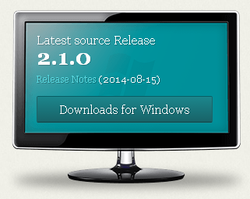

Then, go to the download directory, and run **Git-1.9.4-preview20140815.exe** to setup Git.

We need to check git-cheetah plugin:

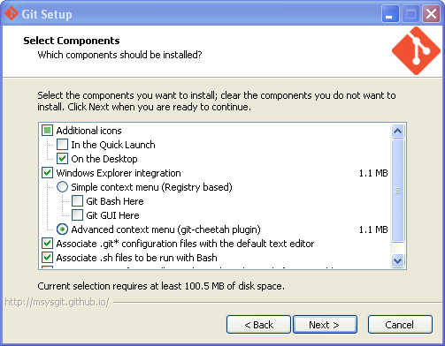

Next => Next

On the "Adjusting your Path Environment", we may want to choose "Use git and optional Unix tools from the Windows Command Prompt" => Next => Next => Finish.

That's it.

Git Configuration

Under **C:\Program Files\Git** directory, we should have the files like this:

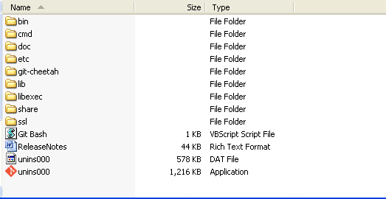

Right click on **Git Bash** on the desk top, to pop up unix style prompt window:

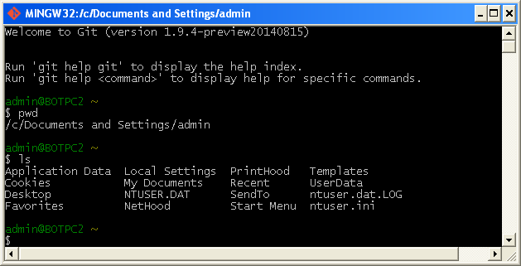

Three stages of File Residency

Git has three main states that your files can reside in: committed, modified, and staged.

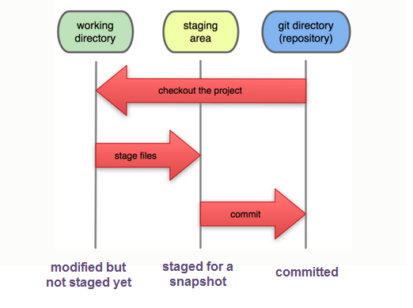

image source: <http://git-scm.com/>

1. Committed - the data is safely stored in our local database.
2. Modified - we have changed the file but have not committed it to our database yet.
3. Staged - we have marked a modified file in its current version to go into our next commit snapshot.

Life Cycle of a File

Each file in our working directory can be in one of two states:

1. Tracked  
   Tracked files are files that were in the last snapshot; they can be unmodified, modified, or staged.
2. Untracked  
   Untracked files are everything else - any files in our working directory that were not in our last snapshot and are not in our staging area.

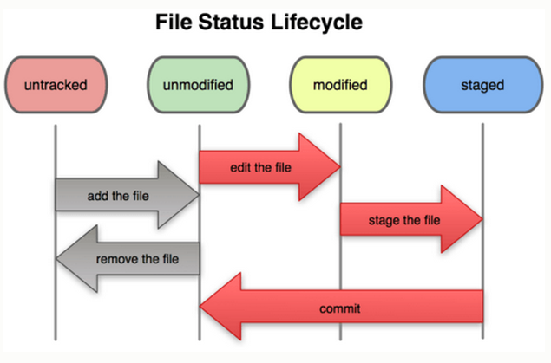

image source: <http://git-scm.com/>

When we first clone a repository, all of our files will be tracked and unmodified because we just checked them out and haven't edited anything.

As we edit files, Git sees them as modified, because we've changed them since our last commit. We **stage** these modified files and then **commit** all our staged changes, and the cycle repeats.